
جامعة القاهرة

إسم الطالب
رقم الطالب


Cairo University

Faculty of Computers and Information

Final Exam

Department: Computer Sciences

Course Title: Artificial Intelligence
Course Code: CS361
Semester: Spring 2015/2016
Instructors: Dr. Khaled Wassif
Dr. Hanaa Bayomi
Date: 25 May 2016
Exam Duration: 2 Hours

Question | Mark | Signature
One
Two
Three
Four
Five

60
Six
Seven
Eight
Nine
Total Marks

Total Marks in Writing:

ممنوع الكتابة فى هذا المثلث

Attempt ALL Questions:

Part (1)
Q1) Mark each statement with T or F in the right side: (10 Marks)
- Rational agents maximize actual performance, while perfect agents maximize expected performance. ( F )  - Table-driven agents are adequate for solving most practical problems. ( F )  - Model-based reflex agents select actions on the basis of the current percept with ignoring the rest of the percept history. ( F )  - Simple reflex agents work only if the environment is fully observable. ( T )  - In some cases, a goal-based agent is inefficient but a utility-based agent can still make rational decisions.  - With problem-solving agents (except contingency problems), a solution is executed without paying attention to percepts.  - The memory requirements of a search strategy are a bigger problem than its execution time. ( T )  - An informed search strategy can find solutions more efficiently than an uninformed strategy. ( T )  - Depth-first search strategy is complete but not optimal. ( F )  - Best-first search is implemented by ordering the nodes in fringe in descending order of evaluation. ( F )  - Greedy search takes the biggest bite possible to reach the goal without worrying about whether this will be best in the long run. ( T )  - An admissible heuristic function is overestimating the cost to reach the goal. ( T )  - A problem with more restrictions on the actions is called a relaxed problem. ( F )  - In many optimization problems, the path to the goal is irrelevant; the goal state itself is the solution.  - Simulated annealing search frequently gets stuck when reaches a point at which no progress is being made.  - A local maximum is a peak that is lower than each of its neighboring states but higher than the global maximum.  - A knowledge-based agent can be described at two levels: knowledge level and logical level.  - Logical entailment is based only on syntax and does not depend at all on logical inference. ( F )  - An inference rule is complete if the conclusion is true in all cases where the premises are true. ( F )  - Resolution is complete for the propositional logic. | ( F )  ( F )  ( F )  ( T )  ( T )  ( T )  ( T )  ( T )  ( F )  ( F )  ( T )  ( F )  ( F )  ( T )  ( F )  ( F )  ( F )  ( F )  ( F )  ( T )
Q2) The first step to design an agent is to specify its task environment as fully as possible. Explain briefly the main dimensions that categorize the task environments. Accordingly, what are the characteristics of Wumpus world environment? (9 Marks)
Categorization dimensions of task environments
  - Fully observable (vs. partially observable): An agent's sensors give it access to the complete state of the environment at each point in time.
  - Single agent (vs. multi-agent): An agent operating by itself in an environment.
  - Deterministic (vs. stochastic): Next state of the environment is completely determined by the current state and the action executed by the agent.
  - Episodic (vs. sequential): In an episodic task environment, the agent's experience is divided into atomic episodes – each episode consists of the agent percept and then performing a single action.
  - Dynamic vs. static: If the environment can change while an agent is deliberating, then we say the environment is dynamic for that agent; otherwise, it is static.
  - Discrete (vs. continuous): A limited number of distinct, clearly defined percepts and actions.
  - Known (vs. unknown): The rules of the game, or physics/dynamics of the environment are known to the agent.
Wumpus World Characterization:
- Fully Observable No – only local perception.
- Single-agent? Yes – Wumpus is essentially a natural feature.
- Deterministic Yes – outcomes exactly specified.
- Episodic No – sequential at the level of actions.
- Static Yes – Wumpus and Pits do not move.
- Discrete Yes.
- Known? Yes.
Q3) Describe the basic components that formally define the problem of a problem-solving agent and show the relation between these components and its state space. (8 Marks)
A problem can be defined formally by five components:
  - The initial state that the agent starts in.
  - A description of the possible actions available to the agent.
  - A description of what each action does; named transition model.
  - The goal test, which determines whether a given state is a goal state.
  - A path cost function that assigns a numeric cost to each path.
The initial state, actions, and transition model implicitly define the state space of the problem.
  - A state space is the set of all states reachable from the initial state by any sequence of actions.
  - A state space forms a graph in which the nodes are states and the arcs between nodes are actions.
  - A path in the state space is a sequence of states connected by a sequence of actions.

Q4) Describe and evaluate A* search strategy. What are the difference between A* and IDA*? (8 Marks)
A* evaluates nodes by combining g(n), the cost to reach the node, and h(n), the cost to get from the node to the goal: f(n) = g(n) + h(n). Since g(n) gives the path cost from the start node to node n, and h(n) is the estimated cost of the cheapest path from n to the goal, then f(n) is the estimated cost of the cheapest solution through n.
Thus, if we are trying to find the cheapest solution, a reasonable thing to try first is the node with the lowest value of g(n) and h(n). It turns out that this strategy is more than just reasonable: provided that the heuristic function h(n) satisfies certain conditions.
Optimal? Yes
  - A∗ is optimally efficient for any given consistent heuristic.
  - No other optimal algorithm is guaranteed to expand fewer nodes than A∗.
Complete? Yes
  - Unless there are infinitely many nodes with f ≤ f(G).
Time complexity? Exponential
Space complexity? Keeps all expanded nodes in memory
IDA* is a simplest way to reduce memory requirements for A∗ is to adapt the idea of iterative deepening to the heuristic search context.
  - Main difference between IDA∗ and standard IDS is that the cut-off used is the f-cost (g + h) rather than the depth.
  - At each iteration, the cut-off value is smallest f-cost of any node that exceeded the cut-off on the previous iteration.
IDA∗ is practical for many problems with unit step costs and avoids the substantial overhead associated with keeping a sorted queue of nodes.
But, IDA∗ suffers from the same difficulties with real valued costs as does the iterative version of uniform-cost search.

Q5) Decide whether each of the following sentences is valid, satisfiable, or unsatisfiable. Verify your decisions using model checking. (5 Marks)
- Smoke ⇒ Fire
S | F | S ⇒ F
T | T | T
F | T | T
T | F | F
F | F | T
Satisfiable

- Smoke Ú Fire Ú ØFire
S | F | ¬ F | S ∨ F ∨ ¬ F
T | T | F | T
F | T | F | T
T | F | T | T
F | F | T | T
Valid

- (Smoke ⇒ Fire) ⇒ (ØSmoke ⇒ ØFire)
S | F | ¬ S | ¬ F | S ⇒ F | ¬S ⇒ ¬F | (S ⇒ F) ⇒ (¬S ⇒ ¬F)
T | T | F | F | T | T | T
F | T | T | F | T | F | F
T | F | F | T | F | T | T
F | F | T | T | T | T | T
Satisfiable

- (Smoke ⇒ Fire) ⇒ ((Smoke Ú Heat) ⇒ Fire)
S | F | Η | S ⇒ F | S ∨ H | (S ∨ H) ⇒ F | (S ⇒ F) ⇒ ((S ∨ H) ⇒ F)
T | T | T | T | T | T | T
F | T | T | T | T | T | T
T | F | T | F | T | F | T
F | F | T | T | T | F | F
T | T | F | T | T | T | T
F | T | F | T | T | T | T
T | F | F | F | F | T | T
F | F | F | T | F | T | T
Satisfiable

- ((Smoke ∨ Heat) ⇒ Fire) ⇔ ((Smoke ⇒ Fire) ∨ (Heat ⇒ Fire))

S | F | Η | S ∨ H | (S ∨ H) ⇒ F | S ⇒ F | H ⇒ F | (S ⇒ F) ∨ (H ⇒ F) | ⇔
T | T | T | T | T | T | T | T | T
F | T | T | T | T | T | T | T | T
T | F | T | T | F | F | F | F | T
F | F | T | T | F | T | F | T | F
T | T | F | T | T | T | T | T | T
F | T | F | T | T | T | T | T | T
T | F | F | F | T | F | T | T | T
F | F | F | F | T | T | T | T | T
Satisfiable

Part (2)
Q6) in the game tree below, the numbers indicate values for the heuristic evaluation function (in depth search 3 (figure 1) and in depth search 4 (figure 2)). (9 marks)
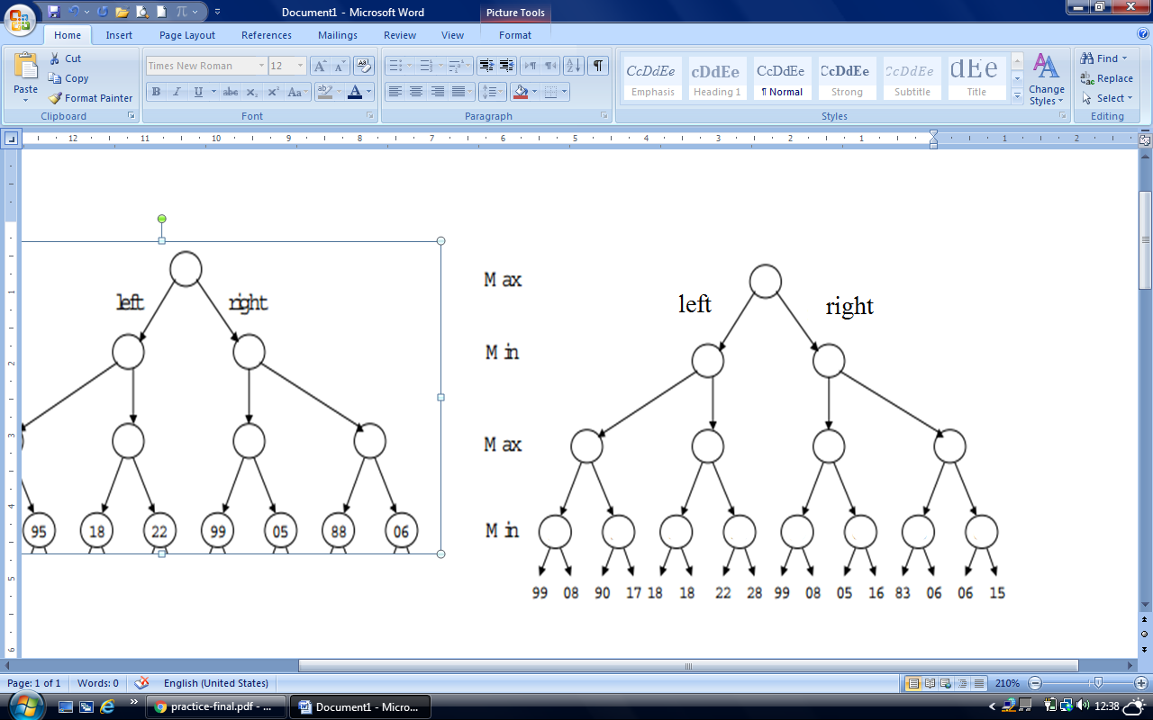
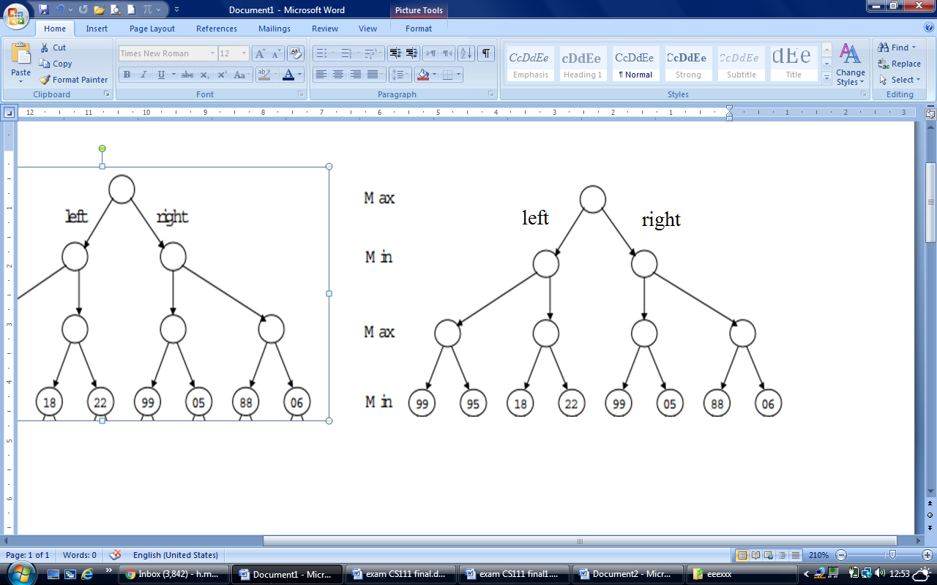

Figure 1
Figure 2

- Should Max choose the left or right branch if the depth of the search is 3 (i.e., Max chooses, Min chooses, Max chooses)? Show the minimax values in the tree. (2 marks)
Right (guarantees an 88)
- Should Max choose the left or right branch if the depth of the search is 4? Show the minimax values in the tree. (2 marks)
Left (guarantees a 17)
- Is the minimax values change when computed via a depth-3 vs. depth-4 search , Explain why. (2 marks)
Yes, because The heuristic function values change (i.e. become more accurate) as search proceeds.
- Using the full tree (figure 2), show alpha-beta pruning by circling all pruned nodes. Assume that nodes are evaluated from left to right. (3 marks)
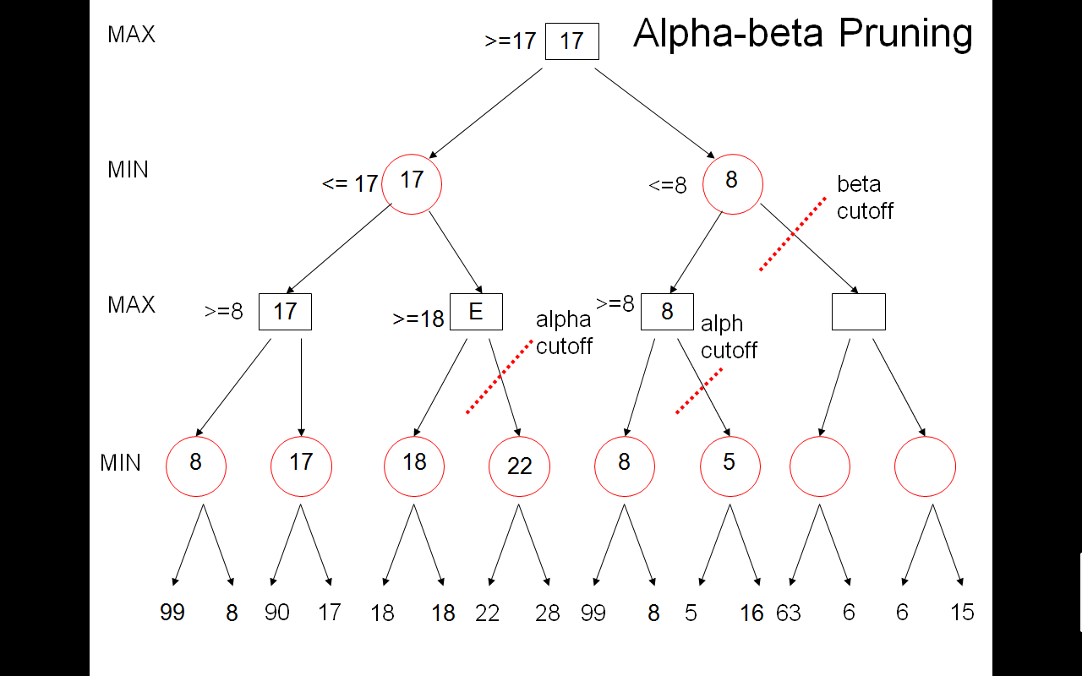

Q7) (7 marks)
- Translate into first-order logic the following sentences. (Remember to define all predicates, functions, and constants.)
- If someone understands someone, then he/she is that someone’s friend.
Understands(x, y) means that x understands y; Friend(x, y) means x is a friend of y.
∀x, y Understands(x, y) ⇒ Friend(x, y)
- All brown horses are slow.

S(x) for slow, H(x) for horse, B(x) for brown
∀x B(x) ∧ H(x) → S(x)

- Translate the following logical statement into good, natural English (no x’s and y’s): (2 marks)
∀ x, y, l SpeaksLanguage(x, l) ∧ SpeaksLanguage(y,l) → Understands(x, y) ∧ Understands(y, x)
If two people speak the same language then they understand each other.

- For each pair of literals below, specify a most general unifier, or indicate that they are not unifiable.

- r(f(x), y) and r(z, g(w))
{z/f(x), y/g(w)}

- r(f(x), x) and r(y, g(y))
not unifiable

3) r(a, john, a) and r(f(x), x, y)

{a/f(x), x/john, y/f(x)}

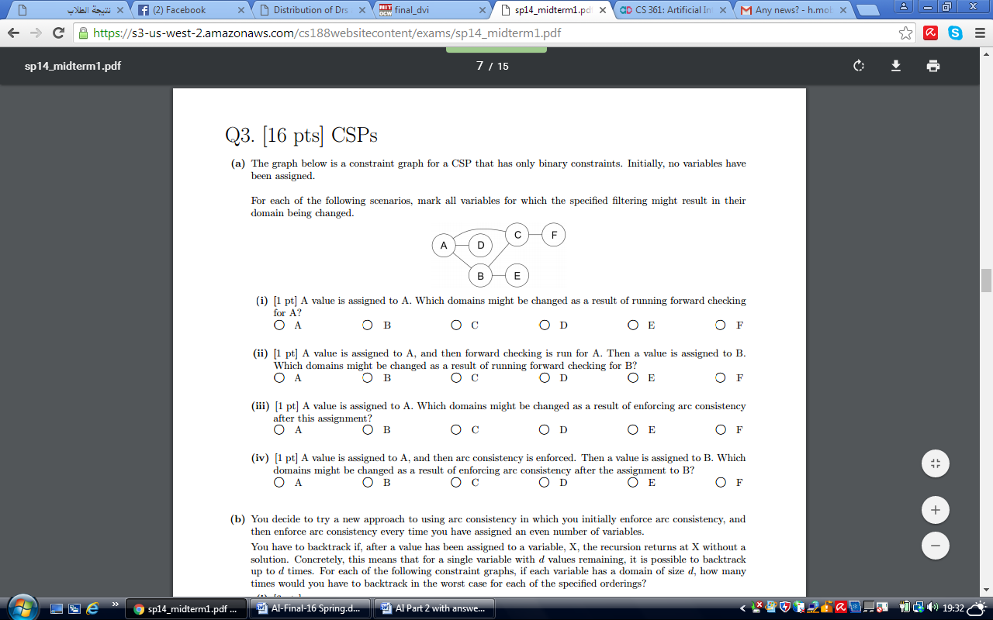
Q8) the graph below is a constraint graph for a CSP that has only binary constraints. Initially, no variables have been assigned. For each of the following scenarios, mark all variables for which the specified filtering might result in their domain being changed.(4 marks)

- A value is assigned to A. Which domains might be changed as a result of running forward checking for A?
( ) A ( ) B ( ) C ( ) D ( ) E ( ) F ( ) No one
- A value is assigned to A, and then forward checking is run for A. Then a value is assigned to B. Which domains might be changed as a result of running forward checking for B?
( ) A ( ) B ( ) C ( ) D ( ) E ( ) F ( ) No one

- A value is assigned to A, and then forward checking is run for A. Then a value is assigned to D. Which domains might be changed as a result of running forward checking for D?
( ) A ( ) B ( ) C ( ) D ( ) E ( ) F ( ) No one
- A value is assigned to A, and then forward checking is run for A. Then a value is assigned to C. Which domains might be changed as a result of running forward checking for C?
( ) A ( ) B ( ) C ( ) D ( ) E ( ) F ( ) No one

With Our Best Wishes

